||JAI SRI GURUDEV||
S.J.C. Institute of Technology, Chickballapur.
Department of Artificial Intelligence and Data Science
TUTORIALS -3
Subject Name & Code: Analysis & Design of Algorithms BCS401

Semester: IV DATE: 24/07/2024

- With an Algorithm, solve the below given graph to compute transitive closure. Drive its time complexity.
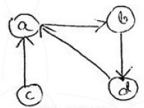
- Design an algorithm to find all pair shortest paths given a weighted connected path using dynamic programming techniques. Apply the same algorithm to compute all pairs of shortest paths for the following weighted connected graph.
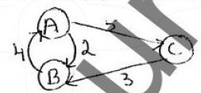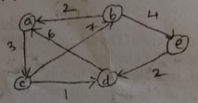
- Design an algorithm to solve knapsack problem using dynamic programming. Apply the same to solve the following knapsack problem where W=50
Item | Weight | value
1 | 10 | 60
2 | 20 | 100
3 | 30 | 120
- Write a dijkstra’s algorithm. Apply same algorithm on the following graph. Drive its time complexity. Initial node is G,
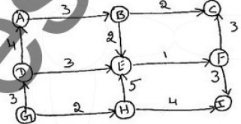
- Define minimum spanning tree. Write prims algorithm to find minimum spanning tree. Apply same on the following graph.
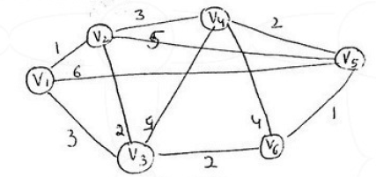
- Write kruskal’s algorithm to find minimum spanning tree. Apply same on the following graph.
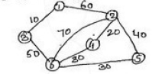
- What is a Huffman code? Briefly explain the two types of encoding schemes. Construct the Huffman tree for following data.
Character | A | B | C | D | E | -
Probability | 0.5 | 0.35 | 0.5 | 0.1 | 0.4 | 0.2
Encode DAD-CBE using Huffman encoding.
- What is backtracking? Write algorithm and Apply backtracking to solve the below instance of sum of subset problem S={5,10,12,13,15,18} d=30.
- Using Branch and Bound technique solve the below instance of knapsack problem.
Item | Weight | Value
1 | 2 | 12
2 | 1 | 10
3 | 3 | 20
4 | 2 | 5
Capacity 5.
- Explain the following with examples
i) P problem
ii) NP Problem
iii) NP- Complete problem
iv) NP – Hard Problems
v) Decision Trees
- What is backtracking? List out two advantages of backtracking strategy. Considering 4-queens problem, provide two possible solutions to this problem using backtracking technique.

